To do list:

Update talk note of 2024 talk (0/4)

Update events page including have note or don’t have note.

When the note is not available, also generate a page to tell the visitor the note is not available because of unpublished content.

Further tidy the image folder, remove useless fig in the folder.

Events page

326\*464

Size of events page photo

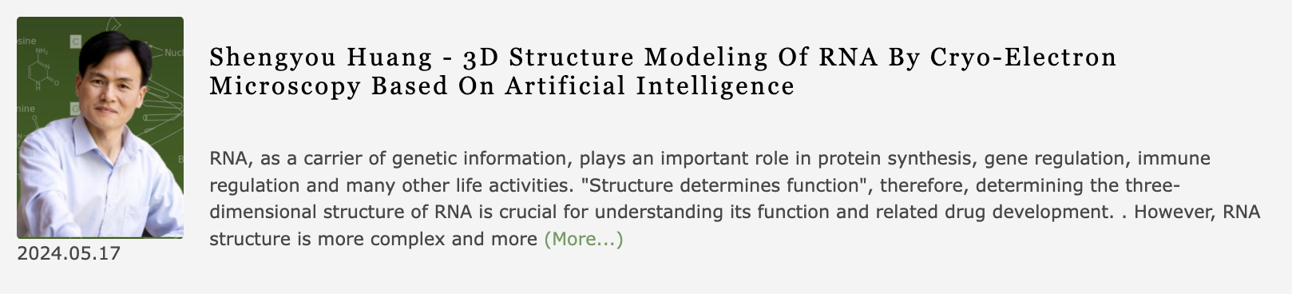

Do not over 3 and half line in this part.